LABOUR MARKET

Employment: Monthly (Seasonally adjusted) | - Western Australia’s employment rose for the third consecutive month in August 2020, driven by increases in both full-time and part-time employment.  - Total employment rose 2.4% (32,188) to 1,350,330 in August 2020, following a rise of 1.5% (19,034) in July 2020.  - Full-time¹ employment rose 0.6% (5,130) to 899,348 in August 2020.  - Part-time² employment rose 6.4% (27,058) to 450,982 in August 2020.  - Public administration and safety (up 25,102) had the largest increase in employment between August 2019 and 2020, followed by other services (up 11,827) and accommodation and food services (up 6,227).
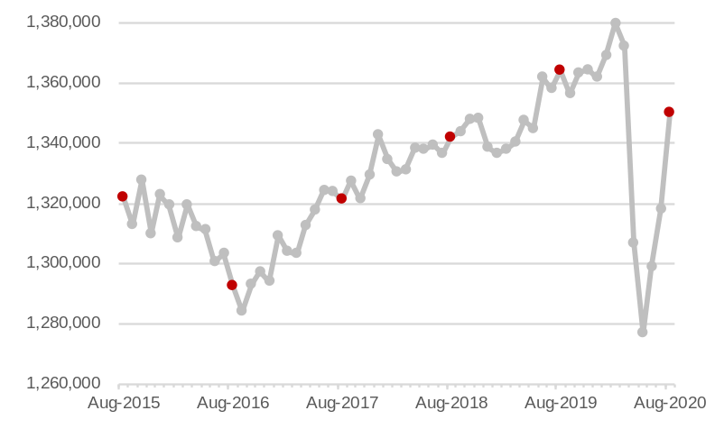
Note – Vertical axis does not start at zero. ¹ Worked 35 hours or more a week. ² Worked less than 35 hours a week.
Source: ABS 6202.0 Labour Force, Australia.

Hours worked: Monthly (Seasonally adjusted)¹ | - Western Australia’s total hours worked rose for the fourth consecutive month in August 2020.  - Actual hours worked in all jobs rose 3.8% (6.8 million) to 188.3 million in August 2020, following a rise of 2.9% (5.1 million) in July 2020.  - Average hours worked per employed person rose 1.3% in August 2020.
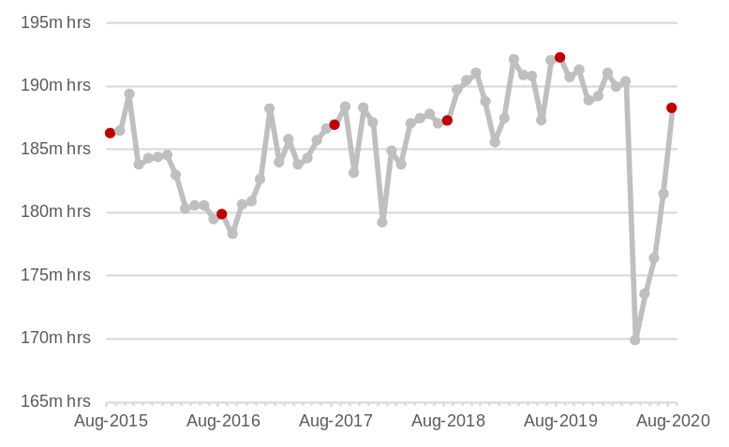
Note – Vertical axis does not start at zero. ¹ Total monthly hours worked in all jobs (full time and part time jobs).
Source: ABS 6202.0 Labour Force, Australia.

Participation rate¹: Monthly (Seasonally adjusted) | - Western Australia’s participation rate increased for the third consecutive month in August 2020.  - The participation rate rose from 67.3% in July 2020 to 67.9% in August 2020.  - The rise in the participation rate reflects an increase in the labour force of 14,148 in August 2020.
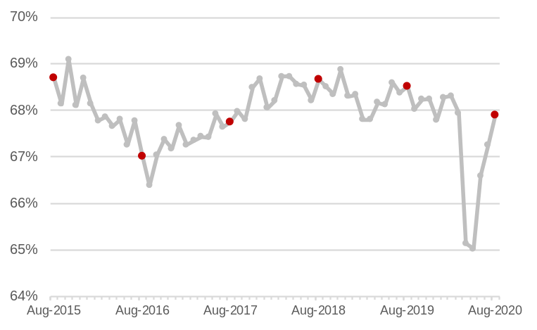
Note – Left vertical axis does not start at zero. ¹ The participation rate is the proportion of the civilian working age population employed or actively looking for work.
Source: ABS 6202.0 Labour Force, Australia.

LABOUR MARKET

Unemployment rate¹: Monthly (Seasonally adjusted) | - Western Australia’s unemployment rate fell for the second consecutive month in August 2020, following four consecutive monthly increases from the beginning of the COVID-19 pandemic.  - The unemployment rate fell from 8.3% in July 2020 to 7.0% in August 2020.  - The number of unemployed people fell 15% (18,039) to 102,031 in August 2020, following a fall of 3% (4,224) in July 2020.  - Accommodation and food services (down 2,820) had the largest decrease in unemployed persons between August 2019 and 2020, followed by mining (down 989) and wholesale trade (down 710).²
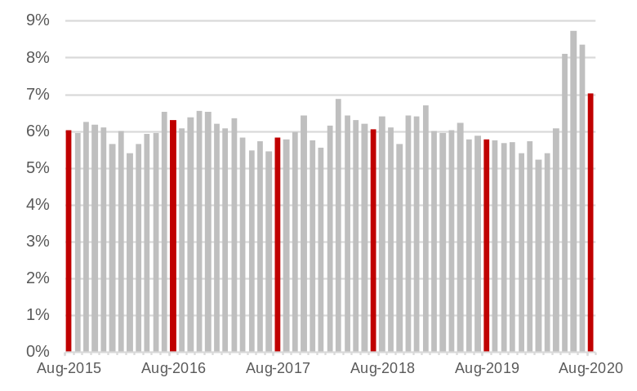
¹ The unemployment rate is the proportion of the labour force actively looking for a job. ² Industry of last job.
Source: ABS 6202.0 Labour Force, Australia.

Underemployment rate¹: Monthly (Seasonally adjusted) | - Western Australia’s underemployment rate declined for the fourth consecutive month in August 2020, as more workers returned to their desired hours of work.  - The underemployment rate fell from 11.6% in July 2020 to 10.4% in August 2020.  - The number of underemployed people fell 8% (12,761) to 139,868 in August 2020, following a fall of 1% (1,200) in July 2020.  - The underutilisation rate, which comprises the unemployment and underemployment rates, fell from 19.0% in July 2020 to 16.7% in August 2020.
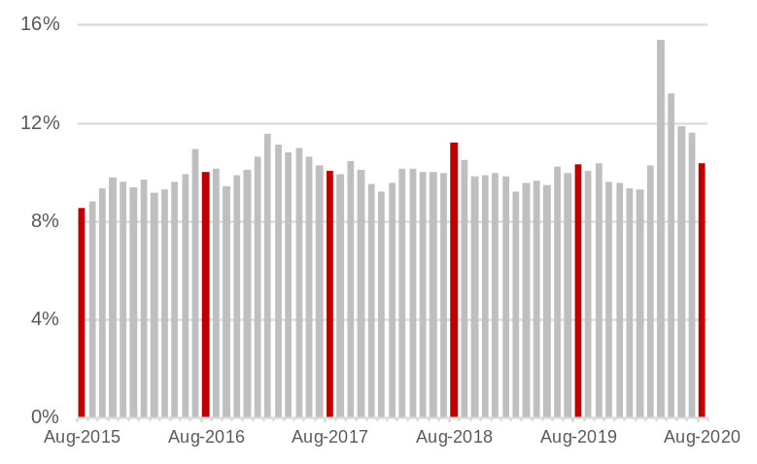
¹ The underemployment rate is the proportion of the labour force with a job but wanting to work more hours.
Source: ABS 6202.0 Labour Force, Australia.

Internet vacancies: Monthly (Seasonally adjusted)¹ | - The monthly Internet Vacancy Report provides a leading indicator of employment.  - Western Australia’s internet vacancies rose for the fourth consecutive month in August 2020 to its highest level since October 2014.  - While employment prospects are improving in Western Australia, labour shortages are starting to effect parts of the economy that rely on overseas and interstate workers.  - Internet vacancies rose 9% (1,394) to 17,408 in August 2020, following a rise of 10% (1,429) in July 2020.  - Internet vacancies of 17,408 in August 2020 were 11% (1,663) above the level of internet vacancies in August 2019.
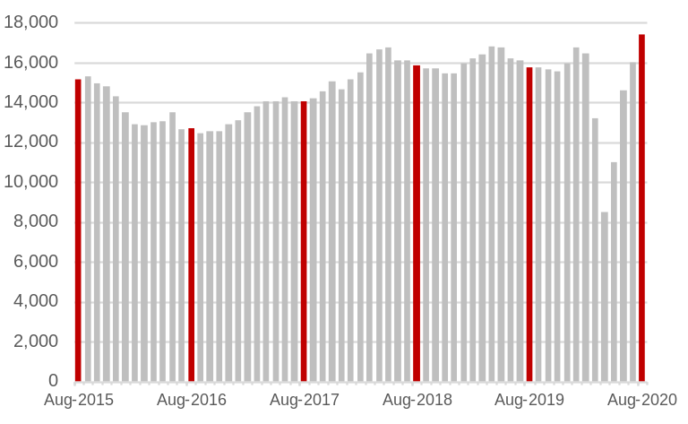
¹ Online job advertisements on SEEK, CareerOne and Australian JobSearch. Excludes job advertisements on other online job boards, employer web sites, newspapers and word of mouth.
Source: Department of Education, Skills and Employment, Vacancy Report.

INTERNATIONAL TRADE

Exports of goods: Monthly (Original)¹ | - The value of Western Australia’s exports fell in August 2020, compared to the previous month. While seasonal factors can influence monthly trade movements, they can be reduced by comparing the value of trade over corresponding months.  - Western Australia exported $14.3 billion of goods in August 2020, 12% lower than August 2019.  - The fall in the value of exports between August 2019 and 2020 was due to non-iron ore exports falling 34% to $4.6 billion, while iron ore exports rose 4% to $9.7 billion.
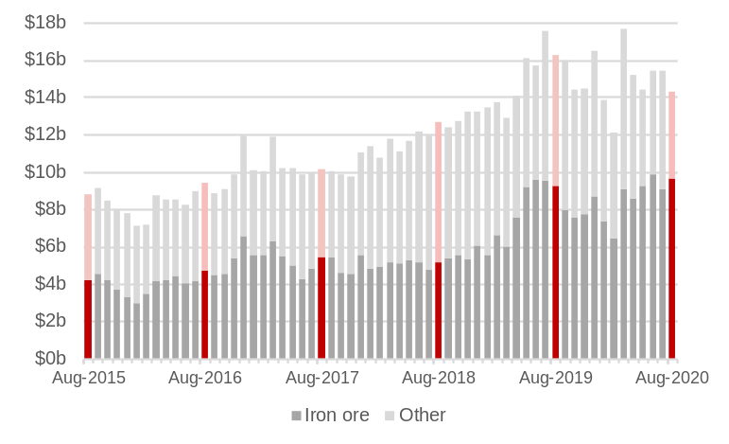
¹ Free on board. Current prices.
Source: ABS 5368.0 International Trade in Goods and Services.

Imports of goods: Monthly (Original)¹ | - Western Australia imported $2.8 billion of goods in August 2020, 18% lower than August 2019.  - The fall in the value of imports² between August 2019 and 2020 was driven by:  - Petroleum (down 42% to $434 million).  - Gold (down 29% to $621 million).  - The largest increase in the value of imports² between August 2019 and 2020 was in machinery and transport equipment, up 2% to $954 million.
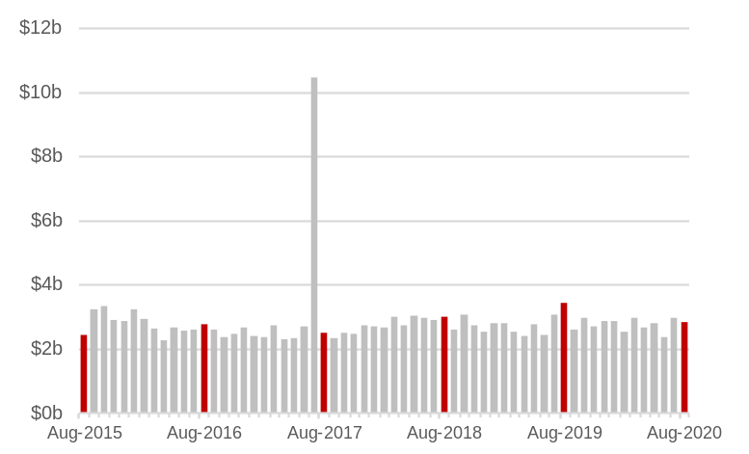
Note – The large value of imports in July 2017 was mainly due to the arrival of the Prelude Floating LNG Plant. ¹ Customs value. Current prices. ² Excluding confidential items.
Source: ABS 5368.0 International Trade in Goods and Services.

Overseas visitors: Monthly (Original)¹ | - Overseas visitors to Western Australia have fallen because of travel restrictions to contain the spread of COVID-19.  - Western Australia had 460 short-term overseas visitors arriving in July 2020, 99.3% (64,800) lower than July 2019.  - There were no arrivals on international student visas in July 2020, a decrease of 9,720 from July 2019.  - Western Australia had 44,527 international students enrolled in July 2020, 4% (1,943) less than July 2019. Many international students arrived before travel was restricted to the State, although ongoing travel restrictions will limit the number of new international student enrolments.
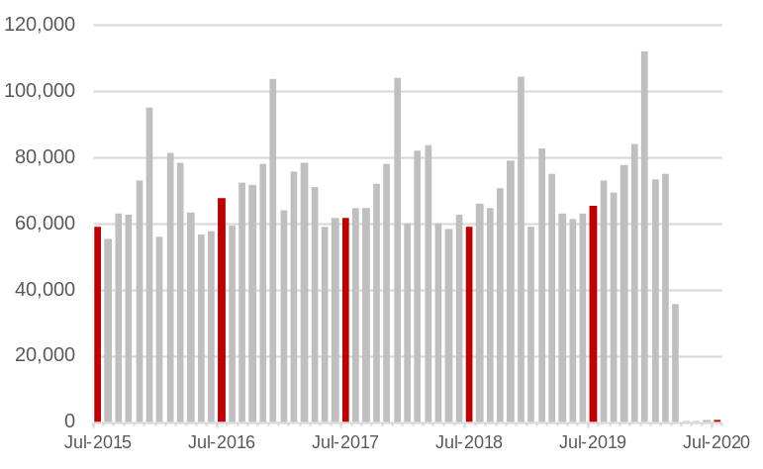
¹ Short-term (less than a year) overseas visitor arrivals.
Source: ABS 3401.0 Overseas Arrivals and Departures, Australia.

RETAIL TRADE AND PROPERTY CONSTRUCTION

Retail turnover: Monthly (Seasonally adjusted)¹ | - Western Australia’s retail trade eased in August 2020 following three successive months of growth.  - Retail trade fell 0.4% to $3.42 billion in August 2020, following a rise of 3.8% in July 2020. The fall in August was driven by:  - Household goods (down 3% to $609 million).  - Clothing, footwear and personal accessories (down 4% to $203 million).  - Department stores (down 2% to $187 million).  - Food (down 0.2% to $1.41 billion).  - Retail trade rose on cafes, restaurants and takeaway food services (up 3% to $532 million) and other retailing² (up 1% to $474 million) in August 2020.
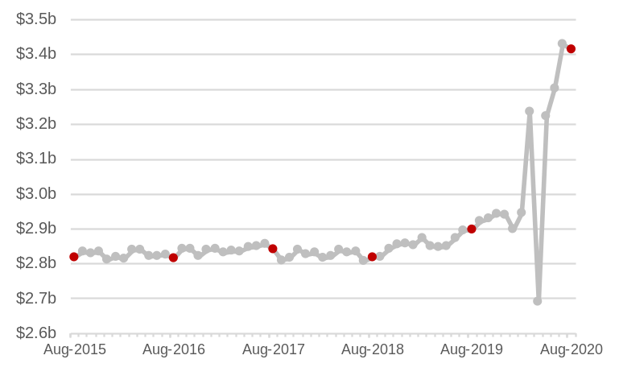
Note – Vertical axis does not start at zero. ¹ Current prices. ² Includes newspapers and books; other recreational goods; pharmaceutical, cosmetic and toiletry goods; and other retailing.
Source: ABS 8501.0 Retail Trade, Australia.

Dwelling approvals: Monthly (Seasonally adjusted)¹ | - The WA Government’s housing stimulus package and the Australian Government’s Homebuilder Scheme have contributed to an increase in Western Australia’s dwelling approvals in August 2020, which should lead to a rise in dwelling construction in coming months.  - The number of dwelling approvals rose 34% to 1,301 in August 2020, following a fall of 8% in July 2020.  - The value of building approvals rose 35% to $709 million in August 2020, following a fall of 25% in July 2020. In August 2020, the value of approvals for:  - Residential building rose 34% to $469 million.  - Non-residential building rose 39% to $240 million.
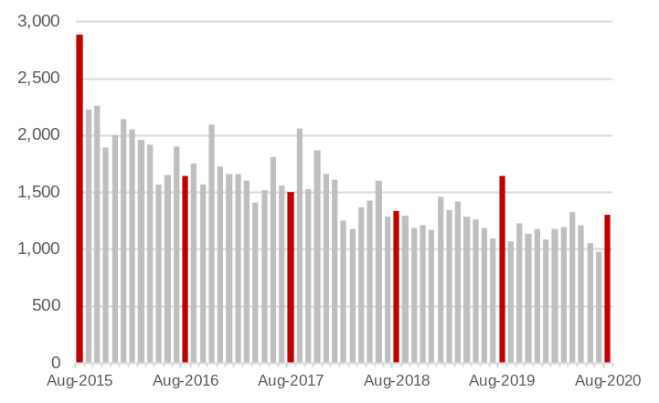
¹ Number of house and other dwelling approvals.
Source: ABS 8731.0 Building Approvals, Australia.

Housing finance: Monthly (Original)¹ | - The WA Government’s housing stimulus package and the Australian Government’s Homebuilder Scheme are contributing to a recovery in housing finance in Western Australia.  - The value of housing finance commitments was $1.5 billion in July 2020, 15% higher than in July 2019.  - Between July 2019 and 2020, housing finance commitments for:  - Owner-occupiers rose 17% to $1.3 billion.  - Investors rose 4% to $232 million.  - The value of fixed-term loans to small and medium-sized businesses for constructing or purchasing property was $115 million in July 2020, 44% lower than July 2019.
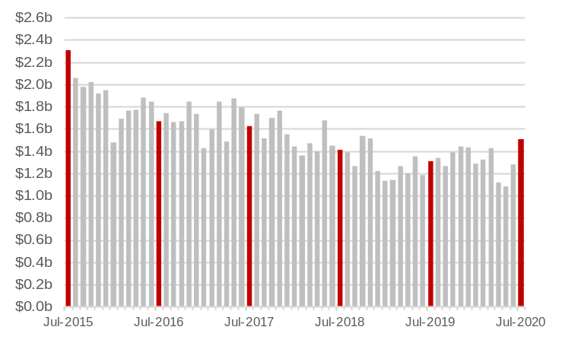
¹ Value of new loan commitments for housing (excluding refinancing) by owner-occupiers and investors.
Source: ABS 5601.0 Lending Indicators, Australia.

